Chapter 6

Molecular deep learning at the edge of chemical space

6.1 Abstract

Molecular machine learning models often fail to generalize beyond the chemical space of their training data, limiting their ability to reliably perform predictions on structurally novel bioactive molecules. To advance the ability of machine learning to go beyond the ‘edge’ of their training chemical space, we introduce a joint modeling approach that combines molecular property prediction with molecular reconstruction, enabling us to estimate model generalizability through a new reconstruction-based ‘unfamiliarity’ metric. Via a systematic analysis spanning more than 30 bioactivity datasets, we demonstrate that unfamiliarity not only effectively identifies out-of-distribution molecules but also serves as a reliable predictor of classifier performance. Even when faced with the presence of strong distribution shifts, unfamiliarity yields robust and meaningful molecular insights that go unnoticed by traditional methods. Our findings highlight that joint modelling can be a powerful strategy for extending the reach of machine learning models into uncharted regions of chemical space, advancing the discovery of diverse and novel molecules.

Manuscript in preparation

6.2 Introduction

Molecular machine learning is rapidly gaining traction in early drug discovery^{1–5}. One key objective is identifying novel bioactive molecules (‘hits’) on one or more pharmacological targets⁶. In this context, finding structurally novel hit molecules is crucial for addressing unmet therapeutic needs^{7,8}, ensuring commercial viability⁹, and overcoming drug resistance^{10,11}. We have seen in previous chapters that using prediction confidence as a handle to prioritize data points for screening (be it nanoparticles or small molecules) can be highly effective. However, moving beyond the structural features of the training molecules (e.g., to identify novel bioactive molecular cores) still poses a significant challenge for machine learning models, which often fail when applied to ‘out-of-distribution’ (OOD) molecules.^{12–14} Especially as discrete data, like molecules, quickly leaves the data distribution learned during model training. This is further exacerbated by the scarcity of structurally diverse molecular data with high-quality experimental annotations^{12–15}, due to the costly and time-consuming nature of biochemical experiments. As a result, training sets typically contain only hundreds of molecules, while screening may involve billions of existing, but previously unseen, chemicals to be predicted¹⁶. Dealing with the resulting distribution shifts makes the discovery of structurally novel hit molecules with machine learning a herculean task. In this regard, quantifying how reliable predictions are beyond the ‘edge’ of the explored chemical space holds enormous promise.

Ensuring prediction reliability in prospective hit-screening campaigns has been an active topic of research^{17,18}. A well-established approach involves defining the ‘applicability domain’,^{19,20} which delimits the chemical space of reliable predictions, most often via a threshold on molecular similarity to the training data²¹ (Fig. 1a). However, this method does not incorporate the information learned by the model, and, due to its similarity-based definition, hampers the discovery of structurally novel molecules. Another widely used approach is based on uncertainty estimation^{22,23}, which leverages the model’s prediction confidence, often through probabilistic modeling techniques. While uncertainty estimation allows the consideration of structurally novel molecules in principle, it may provide overconfident predictions when confronted with OOD samples^{14,24,25}. Hence, being able to make reliable predictions on OOD molecules remains one of the core challenges of molecular machine learning in drug discovery.

Here, we offer a fresh perspective on how to better navigate the ‘edge’ of chemical space with deep learning, while accounting for prediction reliability on out-of-distribution molecules. To achieve this, we leverage recent advances in generative deep learning for molecule discovery^{2,26–29}, in particular autoencoders^{27,30,31}. Autoencoders can be trained to encode molecular structures into a lower-dimensional latent space, and subsequently decode them back to their original form^{27,30}. In this work, through joint-molecular modeling (Fig. 1b), we simultaneously train deep learning models to predict molecular properties (e.g., bioactivity) and reconstruct the input molecule in a semi-supervised^{32,33} manner, i.e., by learning from a combination of labeled and unlabeled molecular data.

Our approach breaks with the well-established application of self-supervised learning for generative chemistry²⁷ or performance improvement^{33–37}, by using their reconstruction capabilities as a direct proxy for out-of-distribution estimation^{38–41}. Specifically, we hypothesize that poorly reconstructed molecules are less ‘familiar’ to the model, indicating that they fall outside the distribution learned from the training data.

To quantify how far a molecule deviates from the training distribution, we introduce a new metric, derived from a model’s reconstruction ability, termed unfamiliarity.

In this systematic study, spanning 33 experimentally labeled molecular datasets, we test whether the introduced unfamiliarity metric is a robust indicator of molecular distribution shifts and explore how indicative unfamiliarity is for classifier performance. We hope that our fresh perspective on estimating prediction reliability, complements established concepts such as the applicability domain^{19,20} and uncertainty estimation^{22,23} and can guide the discovery of structurally novel molecules in a more precise and informed manner.

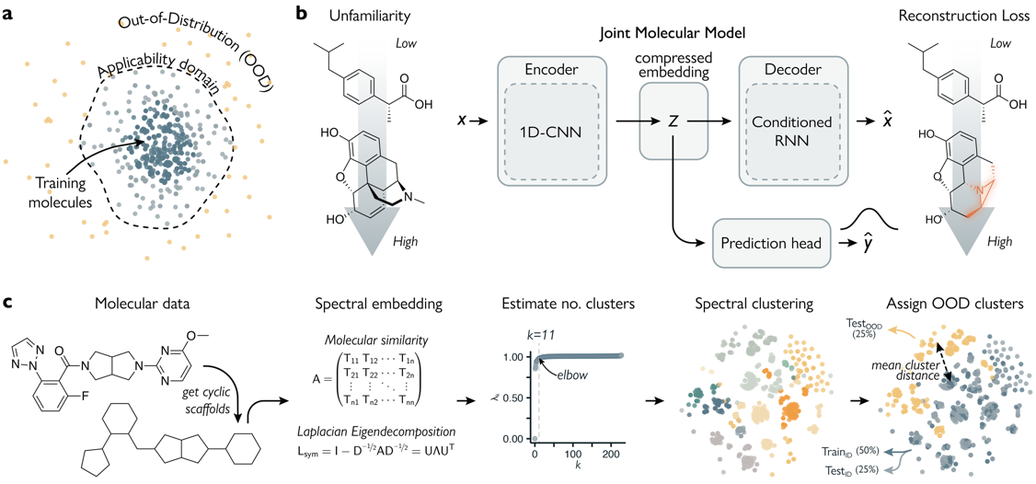 Figure 1 | Estimating unfamiliarity of molecular data using joint modelling. a. Conceptual representation of the applicability domain. Molecules close to the training data in chemical space are within a models’ applicability domain. Molecules outside of this boundary are considered out-of-distribution (OOD). b. The architecture of the Joint Molecular Model (JMM) estimates how ‘unfamiliar’ a molecule is to the model through its reconstruction loss. c. Inducing molecular distribution shifts by separating molecular data into in-distribution and out-of-distribution groups through spectral clustering. Results for the OX2R dataset are shown.

6.3 Results

In what follows, we will elaborate on our Joint Molecular Model (JMM), introduce the unfamiliarity metric, and demonstrate its ability to quantify molecular distribution shifts. Next, we relate molecular property prediction to distribution shifts and leverage this relationship to estimate prediction reliability. Finally, we apply the unfamiliarity metric to prioritize molecules in a virtual screening case study.

Unfamiliarity and joint molecular modeling
The architecture of our Joint Molecular Model (JMM, Fig. 1b) is based on a semi-supervised^{32,33} autoencoder (AE), building on seminal work in molecular generative modelling²⁷. First, molecules are represented as Simplified Molecular Input Line Entry System (SMILES) strings⁴², which encode molecular topology and atom/bond types in a textual format. SMILES strings are encoded into a compressed latent vector ($z$), using a 1-dimensional convolutional neural network⁴³, which was shown to capture elements of bioactivity effectively.^{27,44} The $z$ vector is then decoded back into the input representation using a recurrent neural network,^{26,28,29} in a self-supervised manner. This encoder-decoder was pretrained on ~1.2M unlabeled molecular structures from ChEMBL⁴⁵. For each labeled molecule, the same latent representation ($z$) is passed to an approximate Bayesian classifier,⁴⁶ which predicts molecular properties and simultaneously estimates prediction uncertainty (Fig. 1b). Reconstruction and property prediction are trained jointly (Methods, Eq. 13), to ensure that the shared latent space captures relevant information for both tasks.

The performance of molecular reconstruction was quantified via the reconstruction loss. This was computed as the total negative log-likelihood loss of all SMILES string tokens, normalized by SMILES length:

$${ L}_{reconstruction}(x)=-\frac{1}{|x|}\sum_{i∈x}{\log{p(t_{i}|t_{<i})}}$$ | (1)
where $t_{i}$ is the $i$-th non-padding element (‘token’) in the input SMILES string$x$, and |$x|$ is the number of non-padding tokens in the sequence. From the reconstruction loss, we obtain the interpretable unfamiliarity metric ($U$), as follows:

$$U\left(x\right)=\log{L_{reconstruction}(x).}$$ | (2)
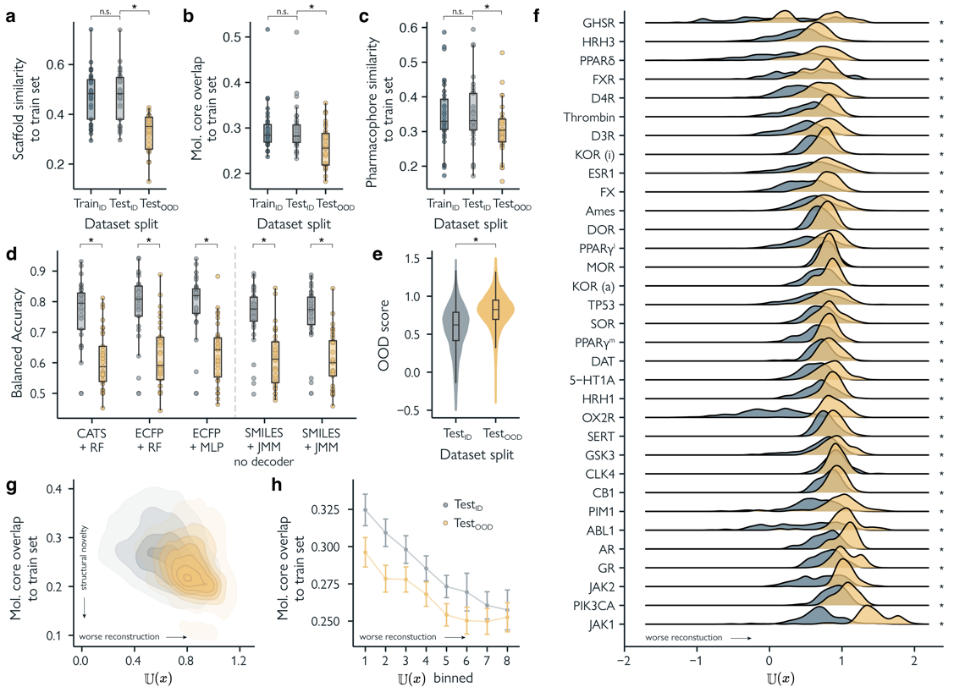 Figure 2 | Detecting induced molecular distribution shifts with the unfamiliarity score. a. Mean scaffold similarity of data splits in the labelled data sets to their train set. Similarity is calculated as the Tanimoto coefficient between ECFPs of Bemis-Murcko scaffolds. Every point in the box plot represents a dataset. b. Mean Maximal Common Substructure Fraction (MCSF) between data splits in the labelled sets to their train set. c. Mean pharmacophore similarity (CATS⁴⁷) between data splits in the labelled sets to their train set. d. Predictive performance on the finetuning sets. From left to right, random forest models using CATS descriptors, random forest using ECFPs, Multi-layer Perceptron (MLP) using ECFPs, MLP using a SMILES string encoder, Joint Molecular Model (JMM) using the same SMILES string encoder. e. Distribution of the JMM’s unfamiliarity score for all molecules in test_{ID} and test_{OOD} in all labelled datasets. f. Distributions of the JMM’s unfamiliarity score in test_{ID} and test_{OOD} per datasets. Statistically significant differences (p < 0.05) in a-f are denoted as *, determined by paired, two-sided, Wilcoxon signed-rank tests (a-d) and two-sided Kolmogorov-Smirnov tests (e, f). g. Relationship between the JMM’s unfamiliarity score and the mean MCSF similarity of all molecules in the labelled datasets to their respective train set. h. Relationship between binned unfamiliarity and MCSF similarities to the respective train set. Points represent the mean over all datasets, error bars represent the standard error.

The unfamiliarity metric theoretically ranges from near −∞ to $\log{(\log\left(V\right))}$, where $V$ is the vocabulary size. The lower the reconstruction loss, the lower the unfamiliarity, and vice-versa. In our case, a model with $V=35$ would have an upper $U$ limit of ~1.27 under ideal circumstances with uniformly predicted token probabilities. However, in practice, this upper bound can be exceeded when a model assigns extremely low probabilities to certain tokens.

Detecting molecular distribution shifts
To verify whether the unfamiliarity score reflects molecular distribution shifts, we collected 33 experimentally-annotated datasets from literature^{48–50}, spanning various biological properties and sizes (Supplementary Table 1). These datasets were split into groups of in-distribution and out-of-distribution molecules. First, we performed spectral clustering (see Methods) on molecular cyclic skeletons⁵¹ (core ring systems without exocyclic substituents), which ensured that structurally similar molecules were consistently grouped together (Fig. 1c). Based on cluster distances in each dataset, the most distant clusters (representing approximately 25% of all molecules) were used as an ‘out-of-distribution’ test set (test_{OOD}). The remaining molecules were split into an in-distribution test set (test_{ID}, ~25% of total) and a training set (train_{ID}, ~50%, Supporting Fig. S1).
Table 1 | Correlation of reliability metrics to train set similarity
Reliability metric | Scaffold similarity | Mol core overlap | Pharmacophore similarity
Unfamiliarity | -0.46±0.03 | -0.32±0.04 | -0.24±0.04
Embedding distance | -0.36±0.03 | -0.56±0.02 | -0.10±0.05
Uncertainty | -0.15±0.04 | 0.02±0.04 | -0.15±0.04
Spearman correlation between three model-based reliability metrics and several test-to-training set similarity metrics. Embedding distance is determined as the Mahalanobis distance of embeddings (z-vectors) to the training set. Mean and SEM for all datasets are reported. Highest correlations are reported in bold.
To confirm that the molecules in the test_{OOD} set originate from different data distributions than the other two sets, we used three approaches to capture molecular similarity:⁵²
- Similarity of extended connectivity fingerprints⁵³ (ECFPs), which capture the presence of atom-centered substructures. ECFPs were computed on molecular cyclic skeletons, and similarity was quantified via the Tanimoto coefficient⁵⁴.
- Overlap of structural cores⁵⁵, computed as the maximal common substructure (MCS) fraction between molecular graphs (see Methods).
- Pharmacophore similarity, computed on Chemically Advanced Template Search (CATS) descriptors⁴⁷, using the cosine similarity.

Across all similarity metrics, molecules in the test_{OOD} set exhibited statistically significant differences from the molecules in the training set and test_{ID}, whereas no differences were found between these latter two (Fig. 2a-c, paired, two-sided, Wilcoxon signed-rank test, p < 0.05).
Table 2 | Correlation of reliability metrics to model performance
 | Rank-based correlation to bin order
Binning metric | Balanced  accuracy | Hit rate | Precision
Scaffold sim | 0.42±0.06 | 0.51±0.04 | 0.50±0.06
Mol core overlap | 0.28±0.07 | 0.22±0.09 | 0.25±0.07
Pharmacophore sim | 0.19±0.07 | 0.37±0.09 | 0.43±0.08
Embedding distance | 0.36±0.06 | 0.24±0.09 | 0.29±0.08
Uncertainty | 0.51±0.08 | 0.62±0.06 | 0.72±0.04
Unfamiliarity | 0.58±0.04 | 0.52±0.07 | 0.52±0.05
Correlation (Kendall’s τ) between several bin-wise performance metrics and the bin order. Molecules are binned into ten bins by: mean pharmacophore similarity to the training set (cosine distance of CATS descriptors), mean scaffold (Tanimoto) similarity to the training set, mean molecular core overlap (MCS fraction) to the training set, Mahalanobis distance of embeddings (z-vectors) to the training set, prediction uncertainty, and unfamiliarity. Mean and SEM for all datasets are reported. A correlation of 1.0 indicates perfect model calibration. For every metric, bins are ordered to reflect low to high confidence. Highest correlations are reported in bold.

To benchmark the effect of such a distribution shift on predictive performance, we trained three well-established⁴⁸ molecular property prediction models using molecular descriptors: a random forest (RF) and a multilayer perceptron (MLP) combined with ECFPs, as well as a RF model combined with CATS pharmacophore descriptors. As expected, the performance of these classifiers consistently degraded on test_{OOD} compared to test_{ID} (Fig. 2d, paired, two-sided, Wilcoxon signed-rank test, p < 0.05) as measured via balanced accuracy (Methods, Eq. 15). Such performance degradation is a hallmark of OOD data⁵⁶.

Having established a baseline, we evaluated the classification performance of the proposed Joint Molecular Model (JMM, Fig. 1b) on each dataset. The JMM achieved a balanced accuracy of 0.75±0.02 on test_{ID} molecules, which was slightly lower than the balanced accuracy of 0.78±0.02 achieved by the ECFP-based model (Fig. 2d, p=3.7e-05, paired, two-sided, Wilcoxon signed-rank test). However, such small a performance gap suggests limited practical differences. This finding aligns with existing literature on the performance of SMILES- vs ECFP-based models⁴⁴. Notably, training the JMM with or without the reconstructive decoder had no effect on the classifier’s performance (test_{ID}: p=0.499, test_{OOD}: p=0.594; paired, two-sided, Wilcoxon signed-rank test). These results indicated that our JMM maintains predictive performance in line with literature standards, despite the addition of the extra task of molecular reconstruction.

Next, we aimed to verify the hypothesis that molecules well-represented in the training data (or test_{ID}) are reconstructed better by our model than ‘unfamiliar’ OOD molecules^{38–41}. To this end, we inferred $U(x)$ on all labeled molecules in the respective test_{ID} and test_{OOD} sets for every trained JMM. As expected, test_{OOD} molecules received significantly higher unfamiliarity scores than test_{ID} molecules (two-sided Kolmogorov-Smirnov Test, p < 0.05, Fig. 2e), as was especially visible on a dataset-basis (Fig. 2f). Importantly, these differences in unfamiliarity were not driven by factors like SMILES string length or complexity, branching, molecular graph complexity, molecular weight, or the number of functional groups (Supplementary Fig. S2). These results suggest that the model’s ability to reconstruct molecules depends not on molecular complexity, but rather on its ‘proximity’ to the training data distribution.

For both molecules in test_{ID} and test_{OOD}, this was further confirmed by the direct relationship between a molecule’s unfamiliarity and its distance to the training data (Supplementary figure S3), e.g., in terms of structural core overlap (Fig. 2g, h). Moreover, we found that in general, there is a moderate to strong, relationship between unfamiliarity and structural distance to the training data (Table 1). In this context, unfamiliarity correlates well to multiple and complementary similarity metrics, suggesting that it provides a generalizable, model-driven perspective on learned data distributions.

Unfamiliarity and bioactivity prediction
Since molecular reconstruction and molecular property prediction depend on the same learned latent representation, we tested how informative $U(x)$ is for assessing the predictive capabilities of the model. We compared our approach with other well-established measures of reliability, namely:
- Similarity to training set molecules (data-driven), measured as the average pharmacophore similarity, cyclic skeleton similarity, or molecular core overlap.
- Embedding distance (model-driven), defined as the average Mahalanobis distance⁵⁷ of a molecule’s embedding $z$ (Fig. 1b) to the learned embeddings of the training set.
- Prediction uncertainty (model-driven), based on approximate Bayesian modeling of the classifier (see Methods, Eq. 12).
We found that all tested reliability metrics are indicative of a model’s predictive performance, considering balanced accuracy, hit rate, and precision (Supplementary Fig. S4). Prediction uncertainty and unfamiliarity, in particular, have a moderate to strong correlation to model performance (Table 2). In other words, when uncertainty and/or unfamiliarity are high, models make more erroneous bioactivity predictions, whereas molecules for which these metrics are low, are generally predicted accurately (Supplementary Fig. S4). Interestingly, unfamiliarity and prediction uncertainty seem to be unrelated as metrics themselves (Supplementary Fig. S5, Spearman correlation, r = 0.10±0.05). This indicates that both metrics capture complementary information about prediction reliability and motivates the introduction of unfamiliarity alongside uncertainty for molecular machine learning.

‘Model-driven’ reliability metrics outperformed all ‘data-driven’ methods that calculate a molecule’s distance to the training set using pre-defined descriptors and metrics. This indicates that models can extract relevant information from their training data that cannot be captured through pre-defined measures of molecular similarity alone. Furthermore, the fact that model-driven metrics gauge prediction reliability better than data-driven metrics underscores the limitations of the routinely used ‘applicability domain’ approach, which typically relies on similarity-based thresholds.

Interestingly, the unfamiliarity score proved to be a considerably better reliability metric than embedding distance to the training embeddings, despite they both capture elements of structural similarity learned by the JMM (Table 1). In other words, the ability of a model to reconstruct a molecule from an internal representation provides more insight into prediction reliability than the ‘internal’ molecular embeddings directly used by the classifier. This suggests that the reconstructing a molecule from an embedding is not only highly informative of prediction reliability, but also of the quality of the embedding itself. These findings corroborate that simple embedding distance metrics fail to capture the ‘chemical nuances’ that affect task-specific outcomes and that embedding quality is better assessed through downstream tasks than by proximity to training embeddings, as previously suggested for computer vision⁵⁸.

Furthermore, our results highlight the distinctions between embedding distance, unfamiliarity, and prediction uncertainty. While both unfamiliarity and prediction uncertainty correlate with performance independently, the latter does not strongly relate to the structural properties of molecules (Table 1). In contrast, unfamiliarity captures both molecular similarity and predictive performance simultaneously. In other words, embedding distance primarily reflects $p(x)$, uncertainty relates to $p(y|x)$, and unfamiliarity integrates both, providing insight into $p(y, x|x)$. This makes unfamiliarity a holistic metric of prediction reliability, effectively linking structural information to prediction confidence.

Virtual hit screening
To test the performance of unfamiliarity as a reliability metric for prospective application, we compared it to the well-established metric of uncertainty estimation in a simulated hit screening campaign. Usually, prediction reliability metrics are used in early drug discovery to prioritize the top-$k$ molecules from a (commercial) screening library for experimental follow-up (i.e., labeling)⁶. Accordingly, we ‘screened’ the top 50 molecules with each JMM from their corresponding test sets according to their distance to the so-called utopia point⁵⁹ (see Methods). These ideal points are the geometric optima for combining the following objectives (Fig. 3a-c):
- High predicted bioactivity $E\left(y | x\right)$ and low prediction uncertainty $H(y|x)$.
- High $E\left(y | x\right)$ and low unfamiliarity $U(x)$.
- High $E\left(y | x\right)$, low $H(y|x)$, and low $U(x)$.

We found that no method showed a clear advantage over the others in terms of performance. Selecting molecules based on low prediction uncertainty (Fig. 3a) achieved the highest screening precision of 0.72 ± 0.03 (Fig. 3d), whereas selecting the least unfamiliar molecules (Fig. 3b) resulted in a slightly lower precision of 0.67 ± 0.03 (Fig. 3d). Combining both reliability metrics (Fig. 3c) yielded a precision of 0.70 ± 0.03 (Fig. 3d). Furthermore, all methods achieved statistically indistinguishable hit rates (Eq. 17, Supplementary Fig. S6), no meaningful difference in hit enrichment (Eq. 18, Supplementary Fig. S6) and no notable differences regarding the structural novelty of the selected top-$k$ molecules (Fig. 3e). This indicated that unfamiliarity and uncertainty can both serve as effective decision handles during virtual screening.

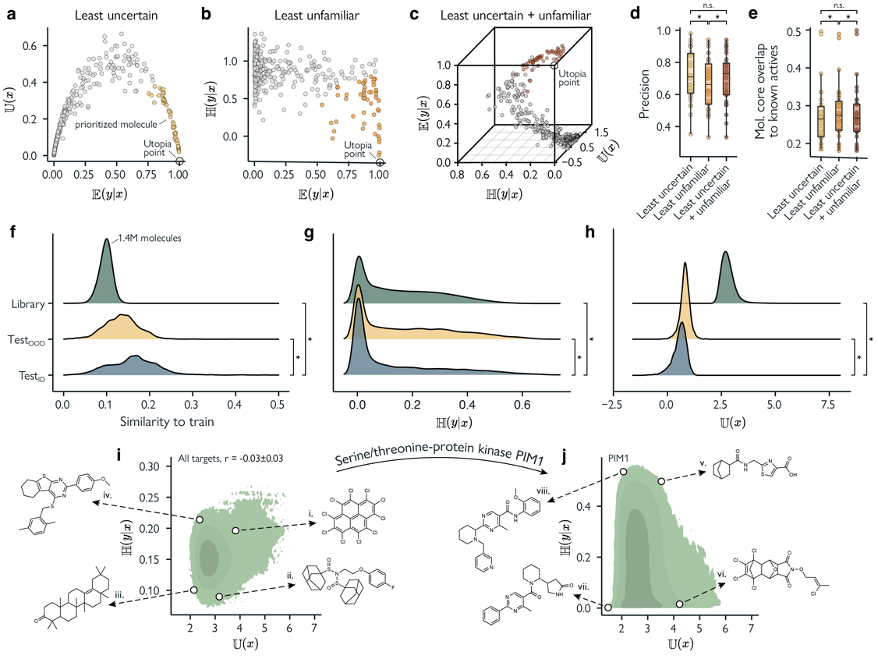Figure 3 | Virtual screening. a-c. The top-k (k=50) molecules from all 33 test sets (test_{ID} + test_{OOD}) are prioritized for screening (i.e., labelling) with three different methods. a. Selecting molecules that have high bioactivity predictions $E(y|x)$ and low prediction uncertainty scores $H(y|x)$. b. Selecting molecules that have high bioactivity predictions and low unfamiliarity $U\left(x\right)$. c. Selecting molecules that have high bioactivity predictions, low prediction uncertainty, and low unfamiliarity. d. Precision on the top-k molecules. e. Mean molecular core overlap of discovered hits in the top-k molecules with known bioactive molecules in the training set. f-l. Performing inference on a combined 1.4M unlabeled molecules from the Enamine hit locator, Specs, and Asinex screening libraries. f. Global distributions of the mean Tanimoto similarity to each respective training set of molecules from test_{ID}, test_{OOD}, and the combined screening libraries. Results of all 33 drug targets are combined. g. Global distributions of estimated prediction uncertainty for all molecules in test_{ID}, test_{OOD}, and the combined screening libraries. h. Global distributions of unfamiliarity scores for all molecules in test_{ID}, test_{OOD}, and the combined screening libraries. i. Global relationship between uncertainty and unfamiliarity for all molecules in the screening libraries, combined over all 33 drug targets. The mean spearman correlation is reported ± SEM. Four molecules predicted as generally bioactive across all drug targets are annotated, each close to a utopia point (e.g., lowest uncertainty and lowest unfamiliarity for molecule iii.). j. Relationship between uncertainty and unfamiliarity for all molecules in the screening libraries, for Serine/threonine-protein kinase PIM1. Four molecules predicted as bioactive for PIM1 are annotated, each close to a utopia point. Statistically significant differences (p < 0.05) are denoted as *, determined by paired, two-sided, Wilcoxon signed-rank tests (d, e), and two-sided Kolmogorov-Smirnov tests (f-h).
To further explore the use of uncertainty and unfamiliarity as reliability metrics, we extended our analysis to large-scale screening libraries to mimic a realistic virtual screening scenario. Unlike the previous analysis, these libraries are unlabeled (and therefore do not allow for performance evaluation), but they contain a much larger and more diverse set of molecules, making them closer to real-world hit discovery applications. Moreover, the increased size of these libraries may help reveal differences that were previously undetectable due to the limited size of the labeled test sets.

Using a combined set of 1.4M molecules from three reliable commercial screening libraries – Asinex, Specs, and Enamine hit locator (Supplementary Table S4) – we performed inference with all 33 trained JMM’s. First, we found that the screening molecules have some structural overlap with the training sets, as indicated by the average similarity of screening molecules to a model’s respective train set (Fig. 3k, Supplementary Fig. S7). Looking at estimated prediction uncertainty, no clear differences between screening molecules and test_{ID} molecules are visible (Fig. 3g). This would suggest that the screening libraries are within a model’s operating limits. However, unfamiliarity scores, on the other hand, indicate the presence of very strong distribution shifts. This is true in general (Fig. 3h), but especially on a dataset basis (Supplementary Fig. S7-9).

Interestingly, as previously observed (Table 1), also on this large-scale library, the estimated prediction uncertainty does not correlate with a molecule’s structural similarity to the training data (Fig. 3i, Spearman correlation, r = -0.04±0.02). Unfamiliarity, on the other hand, shows a moderate relationship to structural similarity (Supplementary Fig. S10, Spearman correlation, r = 0.21±0.02), which is also in line with earlier findings. Finally, prediction uncertainty and unfamiliarity themselves remain independent (Supplementary Fig. S10, Spearman correlation, r = -0.03±0.03). Our findings confirm that the observed trends remain robust across different screening libraries. Moreover, they highlight the ability of unfamiliarity to detect out-of-distribution shifts that routinely employed metrics might fail to capture.

Also, when we examined the molecular makeup of the uncertainty and unfamiliarity landscape, we found stark differences between the two metrics. We inspected chemical structures of predicted hit molecules in their extreme regions from a pan-pharmacological angle (Fig. 3i) and for the well-studied serine/threonine-protein kinase PIM1 as a highlighted case (Fig. 3j). Globally, molecules with high $U\left(x\right)$ scores are structurally atypical, for example illustrated by extreme halogenation and polycyclicity in molecule i. (Fig. 3i) or the presence of unusual adamantyl sulfonamides in molecule ii. (Fig. 3i). Molecules with low $U\left(x\right)$ scores, on the other hand, display key characteristics of bioactive molecules. For example, molecule iii. (Fig. 3i) is a typical steroid-like structure that frequently interacts with proteins across different target classes⁶⁰ and molecule iv. (Fig. 3i) has a core structure that is widely used in bioactive small molecules⁶¹. Such clear structural differences are indiscernible when considering prediction uncertainty alone. We see similar trends across individual protein targets, as exemplified by PIM1. Here, molecules vii. and viii. (Fig. 3j) with low $U\left(x\right)$ scores pass for unassuming kinase inhibitors, both containing classic kinase inhibitor pharmacophores with a pyrimidinone core⁶². Again, molecules with high $U\left(x\right)$ scores show unusual structural characteristics. For example, molecule v. (Fig. 3j) contains an unusual norbornyl amide and molecule vi. (Fig. 3j) features an exotic polychlorinated fused ring system – a highly unusual scaffold compared to known PIM1 inhibitors which typically feature aromatic nitrogen-rich heterocycles⁶³.

Interestingly, we found no relationship between unfamiliarity and quantitative estimation of drug-likeness⁶⁴ (QED, Spearman correlation, r = -0.04±0.03) or synthetic accessibility⁶⁵ (SA, Spearman correlation, r = 0.01±0.02), demonstrating that low unfamiliarity scores do not simply capture drug-likeness but express meaningful bioactivity information. Importantly, these chemical insights are not captured by uncertainty estimation. This leads us to believe that uncertainty estimation is unreliable on strongly out-of-distribution data, as has been suggested before^{14,24,25}. Since unfamiliarity inherently captures distribution shifts in a natural way, it is a more robust decision handle for prospective applications, especially when faced with large screening libraries with unseen chemical structures. Ultimate, unfamiliarity offers complementary, and in some cases, superior molecular insights compared to existing methods and could accelerate the discovery of new bioactive molecules at the ‘edge’ of a model’s known chemical space.

6.4 Discussion
This study introduced a new metric that captures a molecule’s distance from the data distribution learned by a deep learning model, which we termed ‘unfamiliarity’. Unfamiliarity is computed via a joint modeling approach – trained to simultaneously perform molecular reconstruction and property prediction. By capturing the model error in reconstructing previously unseen molecules, unfamiliarity quantifies molecular distribution shifts. Our results demonstrate that unfamiliarity is a reliable and powerful indicator of a model’s prediction reliability when applied to new molecules. As a classification reliability metric, unfamiliarity is as informative as prediction uncertainty estimated via approximate Bayesian modeling, yet the two remain independent. Unlike prediction uncertainty, however, unfamiliarity also captures a molecule’s structural distance from the learned data distribution. Notably, in a large-scale virtual screening campaign, unfamiliarity provided far more meaningful molecular insights than uncertainty estimation when faced with strong distribution shifts. The complementarity of unfamiliarity and prediction uncertainty as reliability metrics highlights unfamiliarity as a valuable tool for molecular machine learning. By capturing distribution shifts beyond standard uncertainty estimation or distance calculation, unfamiliarity is poised to enable more informed and precise exploration of the chemical space, unlocking new opportunities for discovering novel molecular candidates.

In this study, the separation of molecules into in-distribution and out-of-distribution sets was bounded by the molecular composition of existing datasets^{48–50}, which are limited in size and may contain some experimental biases^{66,67}. Availability of large (high-quality) datasets would strengthen our analysis and would allow us to further dissect the complex relationship between molecular reconstruction and molecular similarity, prediction uncertainty, and other model behavior. Moreover, experimental validation of our results could give us additional insights into the unfamiliarity and uncertainty landscape.

Our findings advocate for the adoption of unfamiliarity over traditional, similarity-based methods for applicability domain definition. Moreover, since unfamiliarity bears promise to reveal distribution shifts that would be undetected through molecular similarity or underestimated by uncertainty-based approaches, we recommend its adoption when screening large-scale molecular libraries. Crucially, because the unfamiliarity landscape reveals gaps in a model’s learned distribution, its applications could assist in guiding reinforcement learning applications⁶⁸ or extend beyond ‘one-shot’ virtual screening to iterative approaches such as active learning^{69,70} to guide molecule acquisition. Ultimately, our study highlights the advantages of joint modeling not only in de novo design applications²⁷ but also in capturing structure-activity relationships. The information provided by joint modeling and unfamiliarity is expected to drive the development of more reliable and generalizable models – accelerating the exploration of novel regions in the chemical space with greater confidence and precision.

6.5 Methods

Data pre-processing and analysis.

Molecular representation and description. Each molecular structure in this study was represented as a Simplified Molecular Input Line Entry System (SMILES)⁴² string. Chemically Advanced Template Search (CATS)⁴⁷ descriptor and 2048-bit Extended Connectivity Fingerprints (ECFPs)⁵³ using a radius of 2 were computed for each molecule.

Data collection and curation. 33 labeled datasets of molecular structures with their corresponding experimental target property were used:
- LIT-PCBA⁴⁹ (3 targets). The ESR1 (antagonism), TP53, and PPARγ bioactivity datasets were downloaded from LIT-PCBA⁴⁹ (accessed on August 2023 at https://drugdesign.unistra.fr/LIT-PCBA).
- The Ames mutagenicity dataset⁵⁰ was downloaded from http://pubs.acs.org.
- MoleculeACE⁴⁸ (29 targets). Bioactivity datasets were downloaded from https://github.com/molML/MoleculeACE.
Moreover, small molecules were collected from ChEMBLv33⁴⁵ for model pre-training. Since molecular structures from ChEMBL were used for pretraining, molecules with a Bemis-Murcko scaffold⁷¹ similar to any such scaffold in the labelled datasets (Tanimoto similarity coefficient⁵⁴ on EFCPs larger than 0.7) were removed. This included molecules without a Bemis-Murcko scaffold (i.e., containing no rings).

All bioactivity endpoint of the MoleculeACE⁴⁸ datasets were converted from continuous regression labels into binary classification labels. Molecules with an EC₅₀ or K_{i} of 100nM or lower were labeled as bioactive, whereas less potent molecules were labeled as inactive. For the LIT-PCBA⁴⁹ and Ames mutagenicity dataset⁵⁰, their original binary classification labels were used.

For all datasets, SMILES strings were preprocessed using RDKit v. 2024.3.3⁷². For each SMILES string, stereochemistry tokens as well as salts and solvents (see Supplementary Table 2) were removed. Each molecule was sanitized, neutralized using predefined neutralization reactions (see Supplementary Table 3), and its SMILES string was canonicalized. Disconnected structures, and molecules that contained formal charges, contained complex ring systems (SMILES strings with a ring index of 9 or higher), non-standard isotopes, or any atoms other than Cl, Br, H, C, N, O, F, S, and I were removed. Molecules were removed if they contained more than a hundred tokens in their canonical SMILES string or if they could not be featurized into CATS descriptors and/or ECFP fingerprints. Sizes of datasets before and after data curation can be found in Supplementary Table 1.

Molecular cyclic skeletons. Cyclic skeletons⁵¹ (core ring systems without exocyclic substituents) were extracted from molecules to serve as the most fundamental molecular scaffold representation. From each molecule, Bemis-Murcko scaffolds⁷³ were obtained, removing peripheral substituents. Remaining double bonded exocyclic substituents were then removed, and all atoms and bonds were made generic to obtain the final cyclic skeleton.

Data splitting. The curated molecular structures from ChEMBL were split into a training (80%, n = 1,230,041), a test set (10%, n = 153,755), and a validation (10%, n = 153,755) set, using random splitting. All labelled datasets were split into a training set (~50%), test set (~25%), and out-of-distribution set (~25%). To determine the out-of-distribution molecules, spectral clustering was performed on unique cyclic skeletons (see below). The molecules corresponding to the scaffolds in the clusters with the lowest mean cluster similarity to all other clusters that constituted approximately 25% of the total dataset size were taken as the out-of-distribution set. The remaining molecules (i.e., the ~75% most similar molecules) were split randomly in a train and test set, with the test set being equal in size to the out-of-distribution set. An overview of all datasets can be found in Supplementary Table 1.

Spectral clustering.
Spectral clustering was performed on a molecular similarity matrix $A$ using Sci-kit learn⁷⁴. $A$ is an $n × n$ matrix where each element $A_{ij}$ is the Tanimoto coefficient $T_{ij}$ between two molecular structures. By using a molecular similarity matrix directly, we bypass the complex, high-dimensional and non-Euclidean nature of molecular structures. From this affinity matrix, the symmetrically normalized Laplacian was constructed as follows:
$L_{sym}=I-D^{{-1}/2}AD^{{-1}/2}$, | (3)
where $I$ is the identidy matrix and $D$ is the degree matrix. Subsequently, eigenvalue decomposition was performed:

$$L_{sym}=UΛU^{T}$$ | (4)
To determine the number of clusters $k$ for spectral clustering, the eigenvalues $λ_{1},λ_{2}, …, λ_{n}$ were sorted in ascending order and the elbow (the point of maximal curvature) of the resulting sequence was estimated using the kneed algorithm⁷⁵. Finally, the spectral embeddings of the data were clustered by taking the top $k$ (smallest) Eigenvectors $U_{k}$, normalizing $U_{k}$ to unit length, and performing $k$-means clustering on all rows ($u_{k})$.

Chemical space visualization. To visualize each labelled dataset, molecules were first encoded as ECFPs. The resulting binary ECFPs were reduced to 100 components using truncated Singular Value Decomposition (SVD) and embedded into a 2-dimensional space using t-SNE (t-distributed Stochastic Neighbor Embedding) with a perplexity value of 30.

Maximal Common Substructure Fraction. To compute molecular core similarity, we computed the maximal common substructure (MCS) fraction⁵⁵ between a molecule $M_{a}$ and a reference molecule $M_{b}$ as:

$$\text{MCS fraction} = \frac{|MCS(M_{a}, M_{b})|}{|M_{a}|},$$ | (5)

where $|M_{a}|$ is the number of atoms in $M_{a}$ and $MCS$ is the maximal common substructure between the two molecules $M_{a}$ and $M_{b}$, as determined by the FMCS algorithm⁷ in RDKit. A high MCS fraction indicates that a molecule shares a significant portion of their overall core structure with a reference molecule. This implementation is asymmetric.

Molecular complexity. To quantify molecular complexity we compute the well-established Bertz complexity⁷⁶ and Böttcher complexity⁷⁷. Additionally, to align complexity measures with the task of reconstructing SMILES strings, we also estimated the complexity of the molecular graph directly⁷⁸ as:

$C_{graph} = V\log_{2}V - \sum_{i∈G}{V_{i}\log_{2}p_{i}}$, | (6)
where $G$ represents the molecular graph, $V$ is the total number of elements in the graph, and $V_{i}$ is the number of the elements in the $i\text{-th}$ set of elements. In a similar fashion, we also estimated the complexity of a SMILES string, via their entropy computed as

$$C_{SMILES} = - \sum_{i∈S}{p_{i}\log_{2}p_{i}},$$ | (7)
where $S$ represents the set of unique tokens in a SMILES string, and $p_{i}$ is the probability of the $i\text{-th}$ token occurring in $S$. Tokens representing start, end-of-sequence, and padding were not considered. Moreover, for each molecule, we counted the number of SMILES tokens (excluding padding), the number of SMILES string branches (i.e., ‘(‘ tokens), and the presence of 50 unique molecular patterns⁶⁹.

Virtual screening
Top-$k$ molecules were selected in a multi-objective manner by selecting the $k$ molecules closest to the utopia-point⁵⁹. The distance to this ideal point can be calculated as:

$d_{utopia}=\sqrt{\sum_{i=1}^{n}{{{(norm}_{i})}^{2}}},$ | (8)

where ${norm}_{i}$ is the normalized objective that is either maximized (e.g., predicted bioactivity) or minimized (e.g., prediction uncertainty):

$$\begin{matrix}{norm}_{i} \\ [max]\end{matrix}=\frac{x_{max}-x_{i}}{x_{max}-x_{min}} \text{or } \begin{matrix}{norm}_{i} \\ [min]\end{matrix}=\frac{x_{i}-x_{min}}{x_{max}-x_{min}}. (9)$$

Machine learning.

Encoder. Canonical SMILES strings were encoded by a 1-dimensional CNN. SMILES string character tokens were embedded using a randomly initialized trainable embedding layer of size 128. Several 1-dimensional convolutional layers were used with a stride of 1 and no padding. Each layer was followed by a ReLU activation, standard max pooling with a kernel size equal to that of the convolutional layers, and dropout. Both convolutional and pooling layers used a stride of 1 and no padding. The final output was flattened and compressed to a latent vector ($z$) of size 128 using a fully connected layer. The following hyperparameters were optimized (see hyperparameter optimization): the number of convolutional layers [2, 3], filter size [256, 512], kernel size [6, 8], weight decay on CNN weights [0, $1×{10}^{-4}$], and dropout [0, 0.1].

Decoder. Encoded latent molecular representations in $z$ were reconstructed back to SMILES strings using a conditioned Long Short-Term Memory (LSTM) model. A randomly initialized trainable embedding layer of 128 neurons was used to embed SMILES string character tokens. The following hyperparameters were optimized (see hyperparameter optimization): the number of LSTM layers ${(n}_{layers})$ [2, 3] and the LSTM hidden size ($size_{layers})$ [256, 512]. Models were trained autoregressively without teacher forcing using next token prediction based on the tokens predicted in the previous steps rather than the ground truth tokens. A reconstruction loss normalized for sequence length was used (Eq. 1). To condition the model, the LSTM hidden state $h_{0}$ was initialized with $z$ for every molecule. To correctly match all dimensions of $h_{0}$ ($n_{layers}, size_{layers}$), $z$ was first transformed to $n_{layers} × size_{layers}$ with a fully connected layer, after which it was reshaped into $n_{layers}$ chunks of $size_{layers}$.

Approximate Bayesian Classifier. Labels were predicted from either ECFPs or SMILES strings encoded into latent molecular representations $z$. A multi-layer perceptron (MLP) was used with several fully connected layers and an output layer consisting of two neurons. The number of MLP layers [2, 3] and the MLP hidden size [1024, 2048] were optimized (see hyperparameter optimization). To estimate prediction uncertainty, anchored ensembling⁴⁶ was implemented on the MLP as in our previous work⁶⁹. We used an ensemble of $M=10$ models. For each model, $m∈[1…M]$, we regularized its parameters $θ_{m}$ with a set of “anchored” parameters $θ_{anchor, m}$ that prevent different models in the ensemble to converge to the same parameter space. Each model is initiated with distinct $θ_{anchor}$, which is controlled by different random seeds. The classification loss in our implementation is defined as:

$$L_{MLP}=-\frac{1}{M}\sum_{m=1}^{M}{\underset{\text{prediction}}{\underbrace{\log{p_{m}\left(y | x\right)}}}+\underset{anchoring}{\underbrace{λ{\left\|θ^{m}-θ_{anchor}^{m}\right\|}^{2}}}, } (10)$$

where $λ$ is a regularization coefficient (set to $3×{10}^{-4}$). To estimate the expected value $E$ of each molecule $x$, we take the mean prediction over the whole ensemble, as follows:

$E\left(y | x\right)=\frac{1}{M}\sum_{m=1}^{M}{p_{m}\left(y | x\right)}$. | (11)
Similarly, we estimate prediction uncertainty for each molecule $x$ as the mean entropy $H$ over all models in the ensemble:

$H\left(y | x\right)=-\frac{1}{M}\sum_{m=1}^{M}{p_{m}\left(y | x\right)\log{p_{m}\left(y | x\right)}}.$ | (12)

Joint Molecular Model. Canonical SMILES strings were encoded into compressed latent molecular representations $z$ using the encoder model described above. Subsequently, $z$ was used to perform both molecular property prediction with a classifier and molecular reconstruction using the $z$-conditioned decoder model²⁷. The model was optimized in a joint fashion using the following weighted composite loss function:

$$L_{JMM}=L_{reconstruction}+ γ × L_{MLP,}$$ | (13)
where the scalar $γ$ was set at 0.1 based on preliminary experiments. A regular auto-encoder was used as preliminary experiments showed no performance benefits of the more complex variational auto-encoder⁷⁹ architecture.

Random forest. A random forest classifier was trained on either ECFPs or CATS⁴⁷ descriptors. The following hyperparameters were optimized (see hyperparameter optimization): the number of trees [100, 250, 500, 1000], the maximal tree depth [10, 20, 30, ∞], and the minimal samples per split [2, 5, 10].

Model training

Autoencoders. Encoder-decoder models were (pre)trained to reconstruct SMILES strings of general drug-like molecules from ChEMBL using the Adam optimizer. Mini batches of 256 random molecules were sampled from the training data for 1,000,000 steps using uniform sampling. Gradients were clipped with a max norm of 5. Early stopping with a patience of up to 20 evaluation checkpoints was implemented by monitoring validation loss every 10,000 steps. The model checkpoint with the best validation loss was used.

Classifiers. Classifiers using ECFPs or SMILES strings as input were trained for molecular property prediction on each of the labelled dataset using a similar setup to the autoencoders. However, tenfold Monte Carlo cross-validation was used with 10% validation splits instead of one predefined data split. Mini batches of 64 were resampled during training based on the occurrence of their class with

$$P_{c}=1-\frac{n_{c}}{N},$$ | (14)

where $P_{c}$ is the probability of sampling class $c$, $n_{c}$ is the number of samples of class $c$, and $N$ is the total number of samples. Models were trained for 5000 steps with an early stopping patience of 10 evaluation checkpoints, performed every 10 steps. The model checkpoint with the best validation loss was used. For the random forest control models, molecules were weighted inversely proportionally to their class frequency to mitigate class imbalance during training.

Joint molecular models. Joint models, each consisting of a SMILES string encoder, a decoder, and a classifier (Fig. 1b), were initialized with pretrained weights. The SMILES string encoders and classifiers used weights from models trained on the labeled datasets. For the decoder, decoder weights were used from an autoencoder pretrained on ChEMBL. Using a mini batch size of 64, the joint models were finetuned for 10,000 steps with an early stopping patience of 50 evaluation checkpoints, performed every 20 steps. A learning rate of $3×{10}^{-6}$ was used for the encoder and classifier, whereas a learning rate of $3×{10}^{-7}$ was used for the decoder. No weight decay was applied.

Hyperparameter optimization. Hyperparameters, as specified previously, were optimized for all autoencoders, classifiers (using ECFPs or SMILES strings), and random forest control models using a simple grid search. Tenfold Monte Carlo cross-validation was used, repeatedly using 10% of the training data as a validation split. The hyperparameters of the model with the best mean validation loss was used.

Model evaluation
Predictions were evaluated according to the following performance metrics:

$$\text{Balanced accuracy}=\frac{1}{2}\left(\frac{TP}{TP+FN}+\frac{TN}{TN+FP}\right),$$ | (15)

$$\text{Precision}= \frac{TP}{TP+FP},$$ | (16)

where $TP$ is the number of true positives, $TN$ is the number of true negatives, $FN$ is the number of false negatives, and $FP$ is the number of false positives. In addition, the hit rate (true positive rate) was determined for virtual screening experiments as

$$\text{Hit rate}= \frac{TP}{P},$$ | (17)

and enrichment factor as

$$\text{Enrichment factor}= \frac{TP_{k}}{P/N}.$$ | (18)

Here, ${TP}_{k}$ is the number of true positives in the subset of k prioritized molecules, $P$ is the number of positives in the full dataset, and $N$ is the size of the full dataset.

Hardware and training setup
All experiments were performed on a Lenovo ThinkSystem SD650-N v2 server equipped with Intel Xeon Platinum 8360Y CPUs and NVIDIA A100 (40GB) GPUs. Up to five models were trained in parallel on a single GPU.

6.6 Appendix

Supplementary Table S1 | Dataset summary
Dataset | Name | Pharmacological target | End  point | Curated  size | Train  size | Test_{ID}  size | Test_{OOD}  size
ChEMBL v33⁴⁵ | ChEMBL |  |  | 1,537,551 | 1,230,041 | 153,755
ChEMBL4203⁴⁸ | CLK4 | Dual specificity protein kinase CLK4 | K_{i} | 717 | 427 | 145 | 145
ChEMBL2034⁴⁸ | GR | Glucocorticoid receptor | K_{i} | 726 | 394 | 166 | 166
ChEMBL233⁴⁸ | MOR | μ-opioid receptor | K_{i} | 2,962 | 1,576 | 693 | 693
ChEMBL4616⁴⁸ | GHSR | Ghrelin receptor | EC₅₀ | 638 | 388 | 125 | 125
ChEMBL287⁴⁸ | SOR | Sigma opioid receptor | K_{i} | 1,297 | 735 | 281 | 281
ChEMBL218⁴⁸ | CB1 | Cannabinoid receptor 1 | EC₅₀ | 1,002 | 524 | 239 | 239
ChEMBL264⁴⁸ | HRH3 | Histamine H3 receptor | K_{i} | 2,835 | 1,447 | 694 | 694
ChEMBL219⁴⁸ | D4R | Dopamine D4 receptor | K_{i} | 1,811 | 1,103 | 354 | 354
ChEMBL2835⁴⁸ | JAK1 | Janus kinase 1 | K_{i} | 613 | 309 | 152 | 152
ChEMBL2147⁴⁸ | PIM1 | Serine/threonine-protein kinase PIM1 | K_{i} | 1,443 | 727 | 358 | 358
ChEMBL231⁴⁸ | HRH1 | Histamine H1 receptor | K_{i} | 964 | 528 | 218 | 218
ChEMBL3979⁴⁸ | PPARγ | Peroxisome proliferator-activated receptor gamma | EC₅₀ | 1,109 | 637 | 236 | 236
ChEMBL237⁴⁸ | KOR (a) | Kappa opioid receptor agonism | EC₅₀ | 914 | 518 | 198 | 198
ChEMBL244⁴⁸ | FX | Coagulation factor X | K_{i} | 2,947 | 1,537 | 705 | 705
ChEMBL4792⁴⁸ | OX2R | Orexin receptor 2 | K_{i} | 1,467 | 741 | 363 | 363
ChEMBL1871⁴⁸ | AR | Androgen Receptor | K_{i} | 548 | 350 | 99 | 99
ChEMBL237⁴⁸ | KOR (i) | Kappa opioid receptor inhibition | K_{i} | 2,460 | 1,294 | 583 | 583
ChEMBL262⁴⁸ | GSK3 | Glycogen synthase kinase-3 beta | K_{i} | 835 | 487 | 174 | 174
ChEMBL2047⁴⁸ | FXR | Farnesoid X receptor | EC₅₀ | 623 | 337 | 143 | 143
ChEMBL2971⁴⁸ | JAK2 | Janus kinase 2 | K_{i} | 966 | 524 | 221 | 221
ChEMBL204⁴⁸ | Thrombin | Thrombin | K_{i} | 2,457 | 1,355 | 551 | 551
ChEMBL214⁴⁸ | 5-HT1A | Serotonin 1a receptor | K_{i} | 3,236 | 1,620 | 808 | 808
ChEMBL1862⁴⁸ | ABL1 | Tyrosine-protein kinase ABL1 | K_{i} | 771 | 435 | 168 | 168
ChEMBL234⁴⁸ | D3R | Dopamine D3 receptor | K_{i} | 3,590 | 1,952 | 819 | 819
ChEMBL238⁴⁸ | DAT | Dopamine transporter | K_{i} | 1,015 | 535 | 240 | 240
ChEMBL235⁴⁸ | PPARδ | Peroxisome proliferator-activated receptor delta | EC₅₀ | 2,303 | 1,245 | 529 | 529
ChEMBL4005⁴⁸ | PIK3CA | PI3-kinase p110-alpha subunit | K_{i} | 958 | 534 | 212 | 212
ChEMBL236⁴⁸ | DOR | Delta opioid receptor | K_{i} | 2,346 | 1,246 | 550 | 550
ChEMBL228⁴⁸ | SERT | Serotonin transporter | K_{i} | 1,681 | 877 | 402 | 402
ESR1⁴⁹ | ESR1 (a) | Estrogen receptor 1 agonism | AC₅₀ | 3,382 | 1,734 | 824 | 824
TP53⁴⁹ | TP53 | Tumor protein p53 | AC₅₀ | 2,969 | 1,507 | 731 | 731
PPARG⁴⁹ | PPARγ | Peroxisome proliferator-activated receptor gamma | AC₅₀ | 3,546 | 1,894 | 826 | 826
Ames mutagenicity⁵⁰ | Ames |  | Muta-  genicity | 5,125 | 2,576 | 1,274 | 1,274

Supplementary Table S2 | Removed salts and solvents based on Simplified Molecular Input Line Entry System (SMILES) string matching.
Solvent name | SMILES pattern
Trifluoroacetic acid | O=C(O)C(F)(F)F
Oxalic acid | O=C(O)C(=O)O
Fumaric acid | O=C(O)/C=C/C(=O)O
Sulfuric acid | O=S(=O)(O)O
Maleic acid | O=C(O)/C=C\\C(=O)O
Acetic acid | CC(=O)O
Formic acid | O=CO
Triethylamine | CCN(CC)CC
Perchlorate anion | [O-][Cl+3]([O-])([O-])[O-]
Tartaric acid | O=C(O)C(O)C(O)C(=O)O
Tosylate anion | Cc1ccc(S(=O)(=O)[O-])cc1
Trifluoroacetate anion | O=C([O-])C(F)(F)F
p-Toluenesulfonic acid | Cc1ccc(S(=O)(=O)O)cc1
Citric acid | O=C(O)CC(O)(CC(=O)O)C(=O)O
Nitric acid | O=[N+]([O-])O
Tetrafluoroborate anion | F[B-](F)(F)F
Triflate anion | O=S(=O)([O-])C(F)(F)F
Hexafluorophosphate anion | F[P-](F)(F)(F)(F)F
Succinic acid | O=C(O)CCC(=O)O
Phosphoric acid | O=P(O)(O)O
Ethanolamine | NCCO
Mesylate anion | CS(=O)(=O)[O-]
Perchlorate anion | [O-][Cl+3]([O-])([O-])O
Methyl sulfate anion | COS(=O)(=O)[O-]
Tris | NC(CO)(CO)CO
Ethanol | CCO
Dimethylformamide | CN(C)C=O
L-Tartaric acid | O=C(O)[C@H](O)[C@@H](O)C(=O)O
Dicyclohexylamine | C1CCC(NC2CCCCC2)CC1
Methane | C
Hydrogensulfate | O=S(=O)([O-])O
Meglumine | CNC[C@H](O)[C@@H](O)[C@H](O)[C@H](O)CO
Pyridine | c1ccncc1

Supplementary Table S3 | Predefined neutralization reactions. SMILES Arbitrary Target Specification (SMARTS) patterns are used to convert charged substructures to their neutralized form.
Functional group | SMARTS pattern | Neutralized form
Imidazoles | [n+;H] | n
Amines | [N+;!H0] | N
Carboxylic acids & alcohol | [$([O-]);!$([O-][#7])] | O
Thiols | [S-;X1] | S
Sulfonamides | [$([N-;X2]S(=O)=O)] | N
Enamines | [$([N-;X2][C,N]=C)] | N
Tetrazoles | [n-] | [nH]
Sulfoxides | [$([S-]=O)] | S
Amides | [$([N-]C=O)] | N
Supplementary Table S4 | Commercial screening libraries
Library | No. molecules
Specsª | 390,113
Asinex^{b} | 552,413
Enamine hit locator^{c} | 452,896
The number of molecules that pass data curation criteria (the same as used for all other molecular data) is reported.
ªProvided by Specs (https://www.specs.net/) on March 2025.
^{b}“All screening compounds”, downloaded from https://www.asinex.com/screening-libraries-(all-libraries) on March 2025.
^{c}Downloaded from https://enamine.net/compound-libraries/diversity-libraries/hit-locator-library-460 on March 2025.

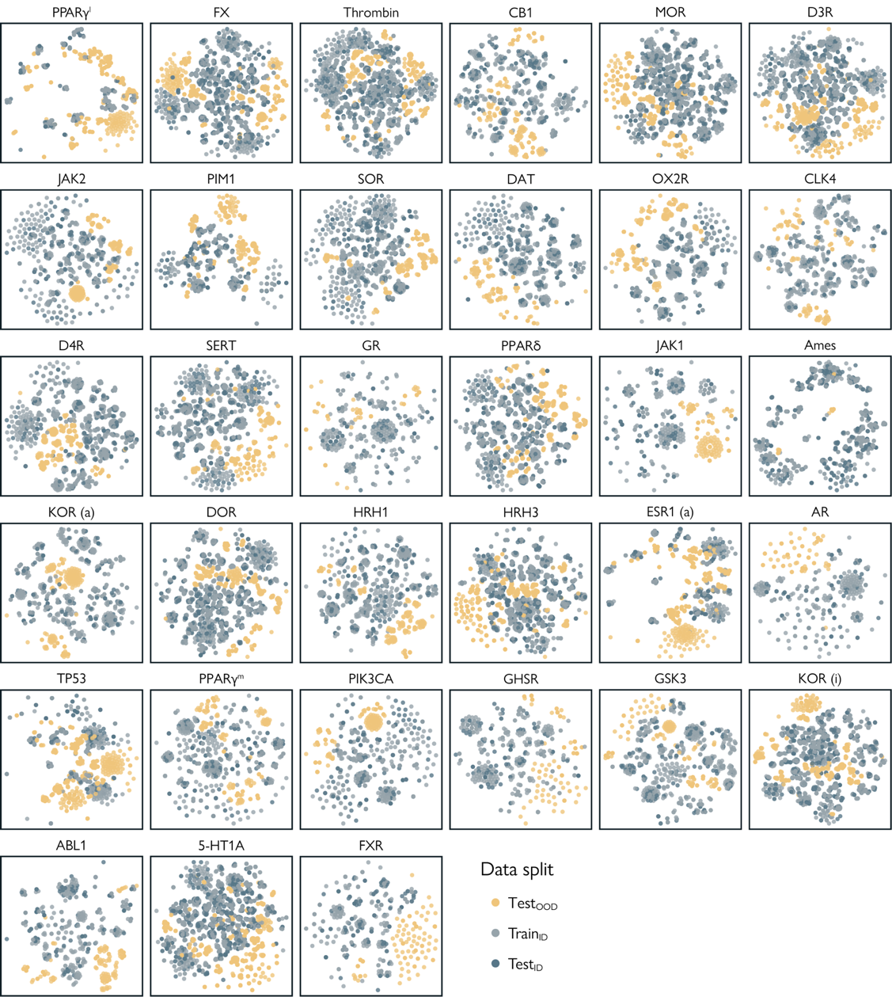 Supplementary Figure S1 | t-distributed stochastic neighbor embedding (t-SNE) of all datasets. Every point is a molecule. Points closer together represent molecules that are structurally similar. See Methods, Chemical space visualization.

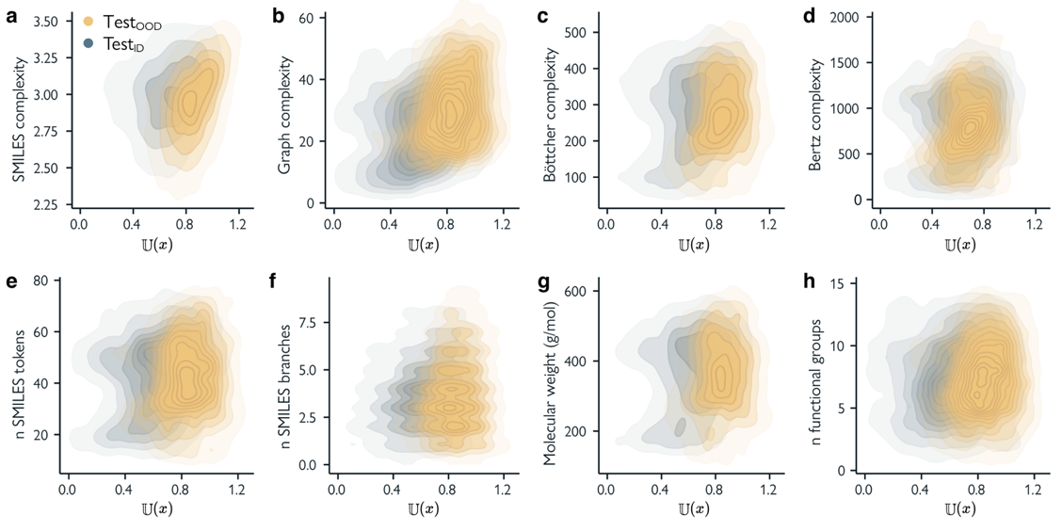
Supplementary Figure S2 | The relationship between unfamiliarity $U(x)$ and various measures of molecular complexity. See Methods, Molecular complexity.

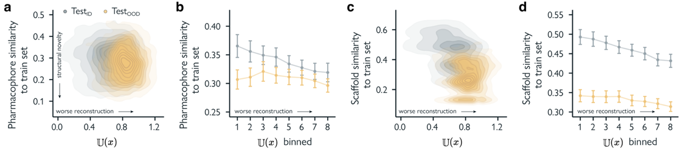
Supplementary Figure S3 | Unfamiliarity and molecular distribution shifts. a, c. Relationship between the JMM’s unfamiliarity score $U(x)$ and the mean pharmacophore similarity (a) and scaffold similarity (c) of all molecules in the labelled datasets to their respective train set. b, d. Relationship between binned unfamiliarity and pharmacophore similarity (b) and scaffold similarity (d) to the respective train set. Points represent the mean over all datasets, error bars represent the standard error.

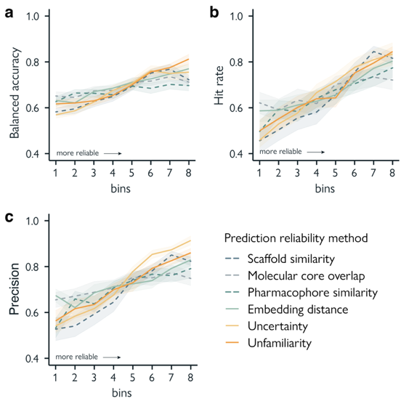
Supplementary Figure S4 | Unfamiliarity as a reliability metric for model predictions. Several reliability metrics are used to bin predictions in increasing order of reliability: mean scaffold (Tanimoto) similarity to the training set, mean molecular core overlap (MCS fraction) to the training set, mean pharmacophore similarity to the training set (cosine distance of CATS descriptors), Mahalanobis distance of embeddings (z-vectors) to the training set, prediction uncertainty, and unfamiliarity. a. Balanced accuracy per reliability bin. b. Hit rate (true positive rate) per reliability bin. c. Precision per reliability bin. Data is represented as the mean ± SEM across all datasets.

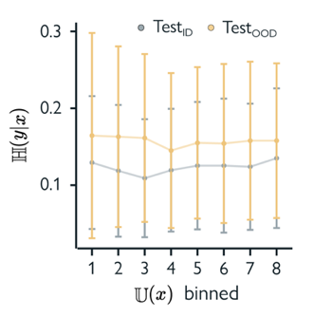
Supplementary figure S5 | The relationship between unfamiliarity $U(x)$ and prediction uncertainty $H(x)$. Predictions are binned in increasing order of reliability. Data is represented as the mean ± SEM across all datasets. The mean Spearman correlation between $H(x)$ and (non-binned) $U(x)$ across all 33 datasets and test sets is 0.1±0.05.

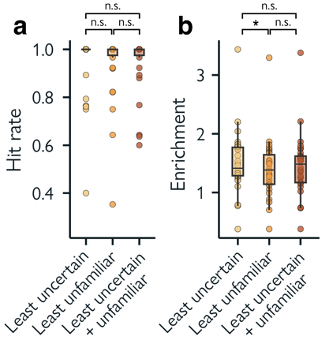
Supplementary figure S6 | Hit rate and enrichment in virtual screening. This is an extension of Fig. 3d-e, where the top-k (k=50) molecules from all 33 test sets (test_{ID} + test_{OOD}) are prioritized for screening (i.e., labelling) with three different methods. a. Hit rate (Eq. 17) on the top-k molecules. b. Enrichment factor (Eq. 18) on the top-k molecules. Statistically significant differences (p < 0.05) are denoted as *, determined by paired, two-sided, Wilcoxon signed-rank tests.
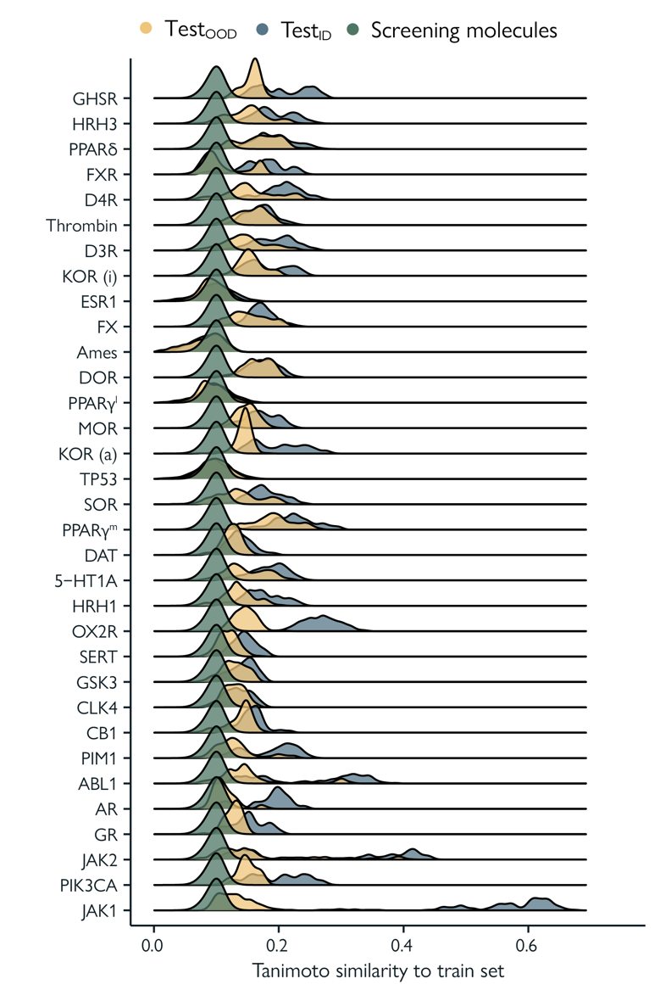
Supplementary figure S7 | Tanimoto similarity to each train set. Distributions of the Tanimoto similarity between train_{ID}, and test_{ID}, test_{OOD}, and a set of 1.4M commercial screening molecules (See Supplementary Table 4).
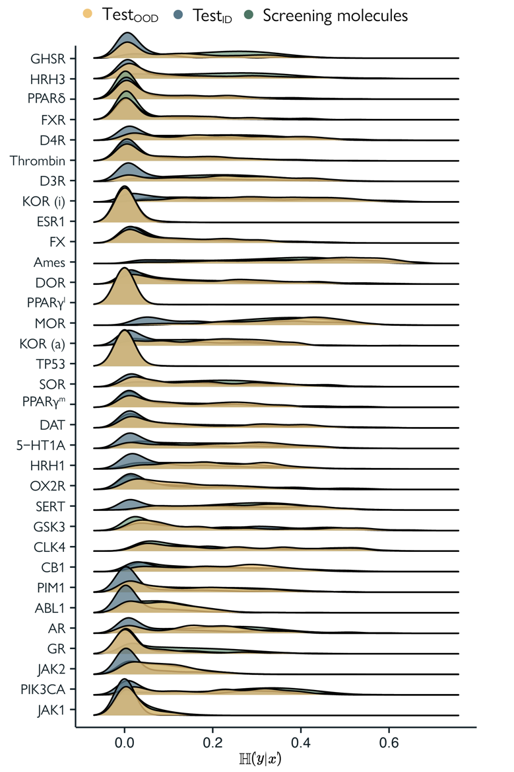
Supplementary figure S8 Uncertainty distributions. Distributions of the JMM’s uncertainty score on test_{ID} and test_{OOD} and a set of 1.4M commercial screening molecules (See Supplementary Table 4).
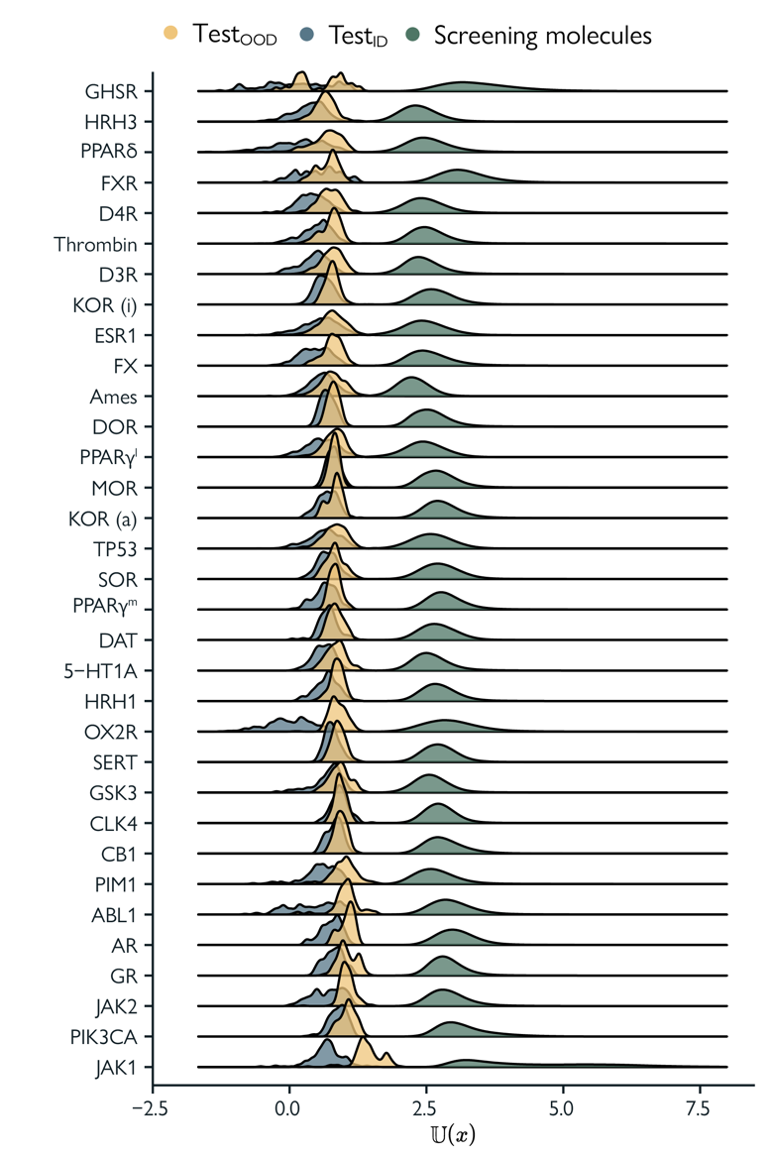
Supplementary figure S9 Unfamiliarity distributions. Distributions of the JMM’s unfamiliarity score on test_{ID} and test_{OOD} and a set of 1.4M commercial screening molecules (See Supplementary Table 4).

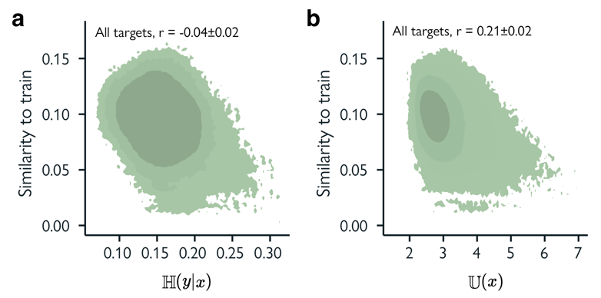
Supplementary figure S10 | Molecular similarity, unfamiliarity, and uncertainty. a. Global relationship between a molecule’s similarity to each respective train set and prediction uncertainty for all molecules in the screening libraries, combined over all 33 drug targets. b. Global relationship between a molecule’s similarity to each respective train set and its unfamiliarity for all molecules in the screening libraries, combined over all 33 drug targets. Spearman correlations are reported as the mean ± SEM across all drug targets.

6.7 References

1. Gawehn, E., Hiss, J. A. & Schneider, G. Deep Learning in Drug Discovery. Molecular Informatics 35, 3–14 (2016).
2. Jiménez-Luna, J., Grisoni, F., Weskamp, N. & Schneider, G. Artificial intelligence in drug discovery: recent advances and future perspectives. Expert Opinion on Drug Discovery 16, 949–959 (2021).
3. Vamathevan, J. et al. Applications of machine learning in drug discovery and development. Nat Rev Drug Discov 18, 463–477 (2019).
4. Stokes, J. M. et al. A Deep Learning Approach to Antibiotic Discovery. Cell 180, 688-702.e13 (2020).
5. Liu, G. et al. Deep learning-guided discovery of an antibiotic targeting Acinetobacter baumannii. Nat Chem Biol (2023) doi:10.1038/s41589-023-01349-8.
6. Walters, W. P., Stahl, M. T. & Murcko, M. A. Virtual screening—an overview. Drug Discovery Today 3, 160–178 (1998).
7. Yera, E. R., Cleves, A. E. & Jain, A. N. Chemical Structural Novelty: On-Targets and Off-Targets. J. Med. Chem. 54, 6771–6785 (2011).
8. Wills, T. J. & Lipkus, A. H. Structural Approach to Assessing the Innovativeness of New Drugs Finds Accelerating Rate of Innovation. ACS Med. Chem. Lett. 11, 2114–2119 (2020).
9. Shimizu, Y. et al. AI-driven molecular generation of not-patented pharmaceutical compounds using world open patent data. J Cheminform 15, 120 (2023).
10. Atanasov, A. G. et al. Natural products in drug discovery: advances and opportunities. Nat Rev Drug Discov 20, 200–216 (2021).
11. Wright, G. D. The antibiotic resistome: the nexus of chemical and genetic diversity. Nat Rev Microbiol 5, 175–186 (2007).
12. Ji, Y. et al. DrugOOD: Out-of-Distribution (OOD) Dataset Curator and Benchmark for AI-aided Drug Discovery -- A Focus on Affinity Prediction Problems with Noise Annotations. Preprint at https://doi.org/10.48550/ARXIV.2201.09637 (2022).
13. Dias, A. L., Bustillo, L. & Rodrigues, T. Limitations of representation learning in small molecule property prediction. Nat Commun 14, 6394 (2023).
14. Tossou, P., Wognum, C., Craig, M., Mary, H. & Noutahi, E. Real-World Molecular Out-Of-Distribution: Specification and Investigation. J. Chem. Inf. Model. 64, 697–711 (2024).
15. Martinez-Mayorga, K. et al. The pursuit of accurate predictive models of the bioactivity of small molecules. Chem. Sci. 15, 1938–1952 (2024).
16. Grygorenko, O. O. et al. Generating Multibillion Chemical Space of Readily Accessible Screening Compounds. iScience 23, 101681 (2020).
17. Nigam, A. et al. Assigning confidence to molecular property prediction. Expert Opinion on Drug Discovery 16, 1009–1023 (2021).
18. Nada, H., Meanwell, N. A. & Gabr, M. T. Virtual screening: hope, hype, and the fine line in between. Expert Opinion on Drug Discovery 1–18 (2025) doi:10.1080/17460441.2025.2458666.
19. Hanser, T., Barber, C., Marchaland, J. F. & Werner, S. Applicability domain: towards a more formal definition. SAR and QSAR in Environmental Research 27, 865–881 (2016).
20. Mathea, M., Klingspohn, W. & Baumann, K. Chemoinformatic Classification Methods and their Applicability Domain. Molecular Informatics 35, 160–180 (2016).
21. Wang, Z. & Chen, J. Applicability Domain Characterization for Machine Learning QSAR Models. in Machine Learning and Deep Learning in Computational Toxicology (ed. Hong, H.) 323–353 (Springer International Publishing, Cham, 2023). doi:10.1007/978-3-031-20730-3_13.
22. Wang, D. et al. Learning with uncertainty to accelerate the discovery of histone lysine-specific demethylase 1A (KDM1A/LSD1) inhibitors. Briefings in Bioinformatics 24, bbac592 (2023).
23. Soleimany, A. P. et al. Evidential Deep Learning for Guided Molecular Property Prediction and Discovery. ACS Cent. Sci. 7, 1356–1367 (2021).
24. Ovadia, Y. et al. Can you trust your model’ s uncertainty? Evaluating predictive uncertainty under dataset shift. in Advances in Neural Information Processing Systems vol. 32 (Curran Associates, Inc., 2019).
25. Scalia, G., Grambow, C. A., Pernici, B., Li, Y.-P. & Green, W. H. Evaluating Scalable Uncertainty Estimation Methods for Deep Learning-Based Molecular Property Prediction. J. Chem. Inf. Model. 60, 2697–2717 (2020).
26. Grisoni, F. et al. Combining generative artificial intelligence and on-chip synthesis for de novo drug design. Sci. Adv. 7, eabg3338 (2021).
27. Gómez-Bombarelli, R. et al. Automatic Chemical Design Using a Data-Driven Continuous Representation of Molecules. ACS Cent. Sci. 4, 268–276 (2018).
28. Merk, D., Friedrich, L., Grisoni, F. & Schneider, G. De Novo Design of Bioactive Small Molecules by Artificial Intelligence. Molecular Informatics 37, 1700153 (2018).
29. Merk, D., Grisoni, F., Friedrich, L. & Schneider, G. Tuning artificial intelligence on the de novo design of natural-product-inspired retinoid X receptor modulators. Commun Chem 1, 1–9 (2018).
30. Hinton, G. E. & Salakhutdinov, R. R. Reducing the Dimensionality of Data with Neural Networks. Science 313, 504–507 (2006).
31. Iovanac, N. C. & Savoie, B. M. Simpler is Better: How Linear Prediction Tasks Improve Transfer Learning in Chemical Autoencoders. J. Phys. Chem. A 124, 3679–3685 (2020).
32. Kingma, D. P., Rezende, D. J., Mohamed, S. & Welling, M. Semi-Supervised Learning with Deep Generative Models. Preprint at https://doi.org/10.48550/ARXIV.1406.5298 (2014).
33. Doersch, C. & Zisserman, A. Multi-task Self-Supervised Visual Learning. in 2017 IEEE International Conference on Computer Vision (ICCV) 2070–2079 (IEEE, Venice, 2017). doi:10.1109/ICCV.2017.226.
34. Assran, M. et al. Self-Supervised Learning from Images with a Joint-Embedding Predictive Architecture. in 2023 IEEE/CVF Conference on Computer Vision and Pattern Recognition (CVPR) 15619–15629 (IEEE, Vancouver, BC, Canada, 2023). doi:10.1109/CVPR52729.2023.01499.
35. Kim, D., Yoo, Y., Park, S., Kim, J. & Lee, J. SelfReg: Self-supervised Contrastive Regularization for Domain Generalization. in 2021 IEEE/CVF International Conference on Computer Vision (ICCV) 9599–9608 (IEEE, Montreal, QC, Canada, 2021). doi:10.1109/ICCV48922.2021.00948.
36. Sun, Y. et al. Test-Time Training with Self-Supervision for Generalization under Distribution Shifts. in Proceedings of the 37th International Conference on Machine Learning 9229–9248 (PMLR, 2020).
37. Albuquerque, I., Naik, N., Li, J., Keskar, N. & Socher, R. Improving out-of-distribution generalization via multi-task self-supervised pretraining. Preprint at https://doi.org/10.48550/ARXIV.2003.13525 (2020).
38. Pimentel, M. A. F., Clifton, D. A., Clifton, L. & Tarassenko, L. A review of novelty detection. Signal Processing 99, 215–249 (2014).
39. Zhou, Y. Rethinking Reconstruction Autoencoder-Based Out-of-Distribution Detection. in 2022 IEEE/CVF Conference on Computer Vision and Pattern Recognition (CVPR) 7369–7377 (IEEE, New Orleans, LA, USA, 2022). doi:10.1109/CVPR52688.2022.00723.
40. Chalapathy, R. & Chawla, S. Deep Learning for Anomaly Detection: A Survey. Preprint at https://doi.org/10.48550/ARXIV.1901.03407 (2019).
41. Ruff, L. et al. Deep Semi-Supervised Anomaly Detection. Preprint at https://doi.org/10.48550/ARXIV.1906.02694 (2019).
42. Weininger, D. SMILES, a chemical language and information system. 1. Introduction to methodology and encoding rules. J. Chem. Inf. Comput. Sci. 28, 31–36 (1988).
43. Jastrzębski, S., Leśniak, D. & Czarnecki, W. M. Learning to SMILE(S). Preprint at https://doi.org/10.48550/ARXIV.1602.06289 (2016).
44. Özçelik, R. & Grisoni, F. A hitchhiker’s guide to deep chemical language processing for bioactivity prediction. Digital Discovery 10.1039.D4DD00311J (2025) doi:10.1039/D4DD00311J.
45. Gaulton, A. et al. ChEMBL: a large-scale bioactivity database for drug discovery. Nucleic Acids Research 40, D1100–D1107 (2012).
46. Pearce, T., Leibfried, F. & Brintrup, A. Uncertainty in Neural Networks: Approximately Bayesian Ensembling. in Proceedings of the Twenty Third International Conference on Artificial Intelligence and Statistics 234–244 (PMLR, 2020).
47. Reutlinger, M. et al. Chemically Advanced Template Search (CATS) for Scaffold‐Hopping and Prospective Target Prediction for ‘Orphan’ Molecules. Molecular Informatics 32, 133–138 (2013).
48. Van Tilborg, D., Alenicheva, A. & Grisoni, F. Exposing the Limitations of Molecular Machine Learning with Activity Cliffs. J. Chem. Inf. Model. 62, 5938–5951 (2022).
49. Tran-Nguyen, V.-K., Jacquemard, C. & Rognan, D. LIT-PCBA: An Unbiased Data Set for Machine Learning and Virtual Screening. J. Chem. Inf. Model. 60, 4263–4273 (2020).
50. Hansen, K. et al. Benchmark Data Set for in Silico Prediction of Ames Mutagenicity. J. Chem. Inf. Model. 49, 2077–2081 (2009).
51. Manelfi, C. et al. “Molecular Anatomy”: a new multi-dimensional hierarchical scaffold analysis tool. J Cheminform 13, 54 (2021).
52. Maggiora, G., Vogt, M., Stumpfe, D. & Bajorath, J. Molecular Similarity in Medicinal Chemistry. J. Med. Chem. 57, 3186–3204 (2014).
53. Rogers, D. & Hahn, M. Extended-Connectivity Fingerprints. J. Chem. Inf. Model. 50, 742–754 (2010).
54. Cereto-Massagué, A. et al. Molecular fingerprint similarity search in virtual screening. Methods 71, 58–63 (2015).
55. Rossen, L., Sirockin, F., Schneider, N. & Grisoni, F. Scaffold Hopping with Generative Reinforcement Learning. Preprint at https://doi.org/10.26434/chemrxiv-2024-gd3j4 (2024).
56. Fooladi, H., Vu, T. N. L. & Kirchmair, J. Evaluating Machine Learning Models for Molecular Property Prediction: Performance and Robustness on Out-of-Distribution Data. Preprint at https://doi.org/10.26434/chemrxiv-2025-g1vjf-v2 (2025).
57. Lee, K., Lee, K., Lee, H. & Shin, J. A Simple Unified Framework for Detecting Out-of-Distribution Samples and Adversarial Attacks. Preprint at https://doi.org/10.48550/ARXIV.1807.03888 (2018).
58. Boix-Adsera, E., Lawrence, H., Stepaniants, G. & Rigollet, P. GULP: a prediction-based metric between representations. Advances in Neural Information Processing Systems 35, 7115–7127 (2022).
59. Gunantara, N. A review of multi-objective optimization: Methods and its applications. Cogent Engineering 5, 1502242 (2018).
60. Welsch, M. E., Snyder, S. A. & Stockwell, B. R. Privileged scaffolds for library design and drug discovery. Current Opinion in Chemical Biology 14, 347–361 (2010).
61. Roskoski, R. Properties of FDA-approved small molecule protein kinase inhibitors: A 2024 update. Pharmacological Research 200, 107059 (2024).
62. Wu, P., Nielsen, T. E. & Clausen, M. H. FDA-approved small-molecule kinase inhibitors. Trends in Pharmacological Sciences 36, 422–439 (2015).
63. Xu, L. et al. Recent Research Advances in Small-Molecule Pan-PIM Inhibitors. Pharmaceutical Fronts 04, e207–e222 (2022).
64. Bickerton, G. R., Paolini, G. V., Besnard, J., Muresan, S. & Hopkins, A. L. Quantifying the chemical beauty of drugs. Nature Chem 4, 90–98 (2012).
65. Ertl, P. & Schuffenhauer, A. Estimation of synthetic accessibility score of drug-like molecules based on molecular complexity and fragment contributions. J Cheminform 1, 8 (2009).
66. Wallach, I. & Heifets, A. Most Ligand-Based Classification Benchmarks Reward Memorization Rather than Generalization. J. Chem. Inf. Model. 58, 916–932 (2018).
67. Holman, L., Head, M. L., Lanfear, R. & Jennions, M. D. Evidence of Experimental Bias in the Life Sciences: Why We Need Blind Data Recording. PLoS Biol 13, e1002190 (2015).
68. Yoshizawa, T. et al. A data-driven generative strategy to avoid reward hacking in multi-objective molecular design. Nat Commun 16, 2409 (2025).
69. Van Tilborg, D. & Grisoni, F. Traversing chemical space with active deep learning for low-data drug discovery. Nat Comput Sci 4, 786–796 (2024).
70. Schmidt, S., Schenk, L., Schwinn, L. & Günnemann, S. Joint Out-of-Distribution Filtering and Data Discovery Active Learning. Preprint at https://doi.org/10.48550/ARXIV.2503.02491 (2025).
71. Bemis, G. W. & Murcko, M. A. The Properties of Known Drugs. 1. Molecular Frameworks. J. Med. Chem. 39, 2887–2893 (1996).
72. Landrum, G. RDKit: Open-source cheminformatics. (2006).
73. Bemis, G. W. & Murcko, M. A. The Properties of Known Drugs. 1. Molecular Frameworks. J. Med. Chem. 39, 2887–2893 (1996).
74. Pedregosa, F. et al. Scikit-learn: Machine Learning in Python. (2012) doi:10.48550/ARXIV.1201.0490.
75. Satopaa, V., Albrecht, J., Irwin, D. & Raghavan, B. Finding a ‘Kneedle’ in a Haystack: Detecting Knee Points in System Behavior. in 2011 31st International Conference on Distributed Computing Systems Workshops 166–171 (IEEE, Minneapolis, MN, USA, 2011). doi:10.1109/ICDCSW.2011.20.
76. Bertz, S. H. The first general index of molecular complexity. J. Am. Chem. Soc. 103, 3599–3601 (1981).
77. Böttcher, T. An Additive Definition of Molecular Complexity. J. Chem. Inf. Model. 56, 462–470 (2016).
78. Bonchev, D., Mekenyan, O. V. & Trinajstić, N. Isomer discrimination by topological information approach. J Comput Chem 2, 127–148 (1981).
79. Kipf, T. N. & Welling, M. Variational Graph Auto-Encoders. arXiv:1611.07308 [cs, stat] (2016).

